Mid-Suburban League Weather Policy

These guidelines represent minimum standards that Mid-Suburban League member schools should follow for athletic competitions and practices when the Wet Bulb Globe Temperature (WBGT) is above 80 degrees Fahrenheit. The IHSA officials and administration, in conjunction with the head athletic trainer, will make the decision to suspend and resume activity for practices and non-state series contests. State series tournament managers will make the decisions to suspend and resume activity in accordance with the IHSA guidelines using those devices or systems usually used at the state series venue/site.

When the weather forecast indicates elevated temperatures, the athletic trainer will take WBGT readings thirty minutes prior to the start of a game or thirty minutes prior to the start of the day’s activities. Once the initial reading is taken, WBGT readings will be taken every 60 minutes until it has been determined the WBGT readings are below the yellow zone.

Minimum restrictions for athletic activity will be established thirty minutes prior to the start of activity. Readings will be recorded in writing and the records will be maintained within the athletics department. Use Table 1 (see below) with an on-site WBGT reading for appropriate exercise modifications during all indoor and outdoor athletic activities.

Table 1
- ≤79.9 degrees F (GREEN ZONE)
- All sports
- 1. Water should always be available and athletes should be able to take in as much water as they desire.
- Optional water breaks every 30 minutes for 10 minutes in duration. Coordinate breaks with assigned contest officials.
- Watch/monitor athletes carefully for necessary action.
- 80.0-84.5 degrees F (YELLOW ZONE)
i. All sports
  - Water should always be available and athletes should be able to take in as much water as they desire.
  - Optional water breaks every 30 minutes for 10 minutes in duration. Coordinate breaks with assigned contest officials.
  - A cooling station (ice towels, shaded areas, etc.) will be made available.
  - Watch/monitor athletes carefully for necessary action
- Contact sports and activities with additional protective equipment (in addition to the above measures)
  - Protective equipment is removed when not necessary for safety (helmets, shoulder pads, or catching gear).
- Reduce time of inside and outside activity. Consider postponing activity to later in the day.
- Thirty minutes prior to the start of an activity, and again 60 minutes after the start of the activity, temperature and humidity readings will be taken at the site of the activity.
- 84.6-87.5 degrees F (ORANGE ZONE)
i. All sports
  - Water should always be available and athletes should be able to take in as much water as they desire.
  - Coaches and officials are encouraged to take a 10:00 break every 30:00 of training or competition.
  - A cooling station (ice towels, shaded areas, etc.) will be made available for before, during, and after exercise/training/competition.
  - Watch/monitor athletes carefully for necessary action
  - If practicing, maximum of 2 hours of training/practice including all breaks from original start time even if WBGT drops below 84.6.
- Contact sports and activities with additional protective equipment (in addition to the above measures)
  - For Practices: Protective equipment is removed when not necessary for safety (helmets, shoulder pads, or catching gear). Football and lacrosse are permitted a maximum of helmet, shoulder pads, and protective gloves. If additional equipment is necessary for safety, suspend activity.
  - For Contests: Helmets and other protective equipment removed if not involved in activity or necessary for safety. If necessary for safety, suspend activity.
- Thirty minutes prior to the start of an activity, and again 60 minutes after the start of the activity, temperature and humidity readings will be taken at the site of the activity.
- 87.6-89.9 degrees F (RED ZONE)
i. All sports
  - Water should always be available and athletes should be able to take in as much water as they desire.
  - Coaches and officials are encouraged to take a 10:00 break every 30:00 of training or competition.
  - A cooling station (ice towels, shaded areas, etc.) will be made available for before, during, and after exercise/training/competition.
  - Watch/monitor athletes carefully for necessary action
  - If practicing, maximum of 1 hour of training/practice while temperature is in this range from the original start time even if the WBGT drops below 87.6
- Contact sports and activities with additional protective equipment (in addition to the above measures)
  - For Practices: Protective equipment is removed when not necessary for safety (helmets, shoulder pads, or catching gear). Football and lacrosse are permitted a maximum of helmet, shoulder pads, and protective gloves. If additional equipment is necessary for safety, suspend activity.
  - For Contests: Helmets and other protective equipment removed if not involved in activity or necessary for safety. If necessary for safety, suspend activity.
- Recheck air temperature and humidity every 30 minutes to monitor for increased heat conditions.
- ≥90 degrees F (BLACK ZONE)
i. All sports
  - No training/competition.
  - Cancel and/or postpone activity to cooler time of the day.

NOTE: While most attention will be given to outdoor sports in the fall and spring, indoor venues/facilities (gymnasiums, wrestling rooms, and swimming/diving facilities) that are not air conditioned should not be neglected for the purposes of this policy. Additionally, sometimes conditions will vary for different aspects of the same competition or practice. For example, one part of a cross-country course may be hotter or more humid than other parts. The best course of action for certified athletic trainers and managers is to take a WBGT reading at the place of the most severe conditions.

Protocol for Determining the WBGT Temperature
For the purposes of establishing temperature activity restrictions, WBGT readings will be taken on three different surfaces at the school site—grass, turf, and tennis courts. Decisions about play will be made separately for each surface based on that surface’s WBGT reading. If a team is practicing or competing at the school’s off-site facility (ex. golf or cross-country), the WBGT temperature taken on the grass surface at the school will be used to determine temperature activity restrictions at the off-site location.

The athletic trainer will take WBGT readings thirty minutes prior to the start of a game or thirty minutes prior to the start of the day’s activities. Once the initial reading is taken, WBGT readings will be taken every 60 minutes until it has been determined the WBGT readings are below the yellow zone.

When monitoring the weather with a handheld heat stress monitor the licensed athletic trainer will note the WBGT every 30 seconds for five minutes. The certified athletic trainer will average the ten readings and use that final number to identify which activity restriction zone the current conditions fall under.

Using a Wet Bulb Globe Thermometer or a WBGT temperature is recommend, although a conversion to WBGT can be made from air temperature and relative humidity using chart 2.

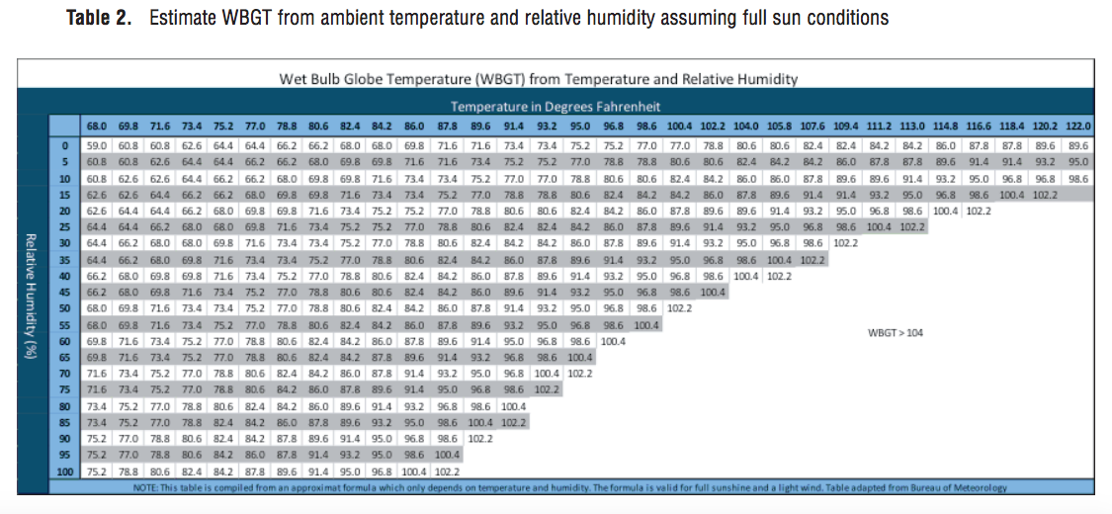

District administration will determine an alternate way to obtain a WBGT reading when an athletic trainer is unavailable to determine a WBGT temperature (ex. summer baseball game) or if the school’s WBGT is broken or malfunctioning. The alternate reading will be used only when a WBGT reading obtained by the school’s athletic trainer is not available. It will not be used as a basis for making activity restrictions that are in contradiction to the WBGT temperature obtained by the athletic trainer.

Lightning
Lightning detection systems should be used to determine proximity and activity of lightning. If the lightning detection system sounds, teams should move indoors immediately. Teams may return outdoors once the lightning detection system signals an “all-clear”.

If a lightning detection system is not available, or does not function properly, teams should move indoors once lightning is visible, or thunder is heard. Teams should remain indoors until no lightning/thunder is present for a minimum of 30 minutes.
What is Wet Bulb Globe Temperature?
The WetBulb Globe Temperature (WBGT) is a measure of the heat stress in direct sunlight, which takes into account: temperature, humidity, wind speed, sun angle and cloud cover (solar radiation). This differs from the heat index, which takes into consideration only temperature and humidity and is calculated for shady areas. Military agencies, OSHA and many nations use the WBGT as a guide to managing workload in direct sunlight. (National Weather Service Website)

 | WBGT | Heat Index
Measured in the sun | X
Measured in the shade |  | X
Uses temperature | X | X
Used relative humidity | X | X
Uses wind | X
Uses cloud cover | X
Uses sun angle | X

Why the MSL change from the “heat index” to the “WBGT”?
The Illinois High School Association (IHSA), the governing body of high school athletics in Illinois, recently enacted a new heat guidelines that use the WGBT. In an effort to more closely align with the IHSA, the Mid Suburban League has adopted new heat guidelines. There are several advantages to using a WBGT. First, the WBGT can be taken at a specific location. Using heat index temperatures calculated from positions close to the school, but not at the school or on the actual playing surfaces, does not give as accurate a reading. Playing conditions can vary significantly depending upon the playing surface and its location. Second, the WBGT can be taken inside a venue to gather a heat action temperature reading. Currently we do not have a way to gather a heat index for an indoor location. Additionally, the WBGT uses other weather factors, such as wind and cloud cover, to calculate a more accurate “feels like” temperature. The WBGT is used by OSHA and the United States Military when determining temperature and determining if it is safe to work.

Why are the WBGT action temperatures lower than the heat index numbers?
Because WBGT will account for factors such as wind and cloud cover, the calculated action temperatures are actually lower than the previous heat index temperatures. Therefore, the corresponding action levels have been lowered to account for the change.

Why would a practice or contest be allowed to continue when a “heat index” indicates a potential danger?
Because the WBGT uses additional factors such as cloud cover, wind, and sun angle to calculate their reading, the OSHA has determined the WBGT is a more accurate representation of actual temperature and the effects on an individual. When using the WBGT, it is possible to continue an outdoor activity even when the “heat index” reading is elevated because wind speed and cloud cover will affect the WBGT reading but will have no effect on the “heat index”.

What if a WBGT reading is not available?
District administration will determine an alternate way to obtain a WBGT reading when an athletic trainer is unavailable to determine a WBGT temperature

What if there is a conflict between WBGT and “heat index” readings? For example, the “heat index” says it is ok to play but the WBGT says practice should be canceled.
When a WBGT temperature is available, the decision to restrict or cancel practices and games will be based upon the WBGT readings and the restrictions table.

